**VOICE CONTROLLED OBSTACLE DETECTOR CAR**

**Hardware Requirements:**

* ARDUNIO
* IR SENSOR
* L293D H-bridge Motor Driver
* IR Obstacle Sensor
* Photo resistor( LDR)
* Bluetooth Module HC-05

**Circuit diagram**

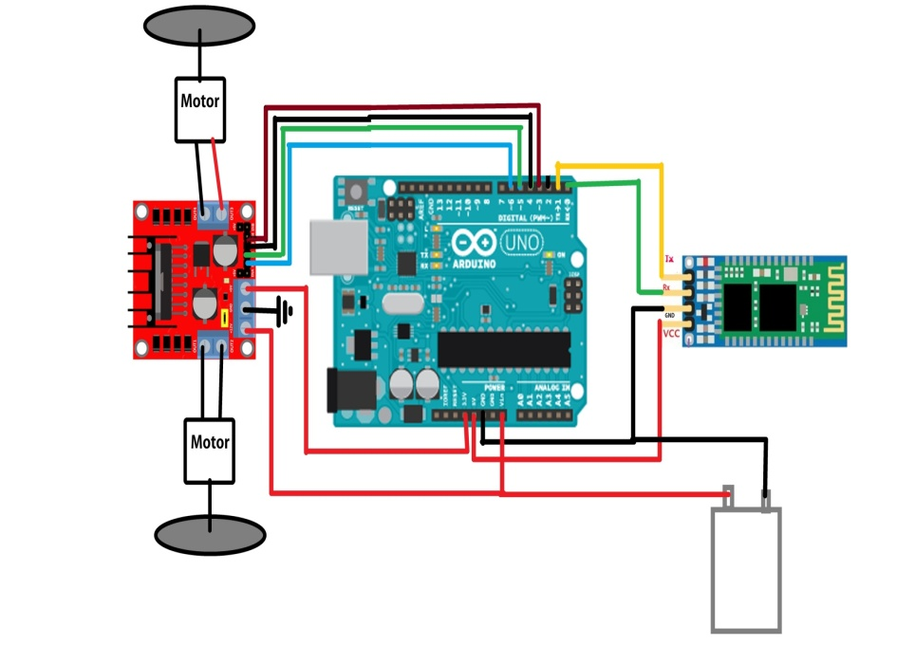

**DONE BY**

**ARAVIND BALAJI.M**

**ARAVINDH.S**

**EBENEZER.R**

**Application:**

1. **Can be used as commercial vehicle**
2. **Can be used as military vehicle**
3. **Even small children can drive these vehicle easily**
4. **Senior citizen can drive these vehicle easily**